Three Body Problem
RULES: USPSA Handgun Competition Rules, Latest Edition COURSE DESIGNER: Kirt McKenna
START POSITION: Standing with feet touch the X’s and wrists below belt.
Handgun is loaded and holstered.
PCC START: Same as handgun with stock on belt and muzzle pointed down range.
STAGE PROCEDURE  On start signal engage targets as they become visible, from within Boxes A, B, or C. | SCORING  SCORING: Comstock, 12 rounds, 60 points  TARGETS: 6 IPSC  SCORED HITS: 2 Best per IPSC  START-STOP: Audible - Last shot  PENALTIES: Per current USPSA rulebook

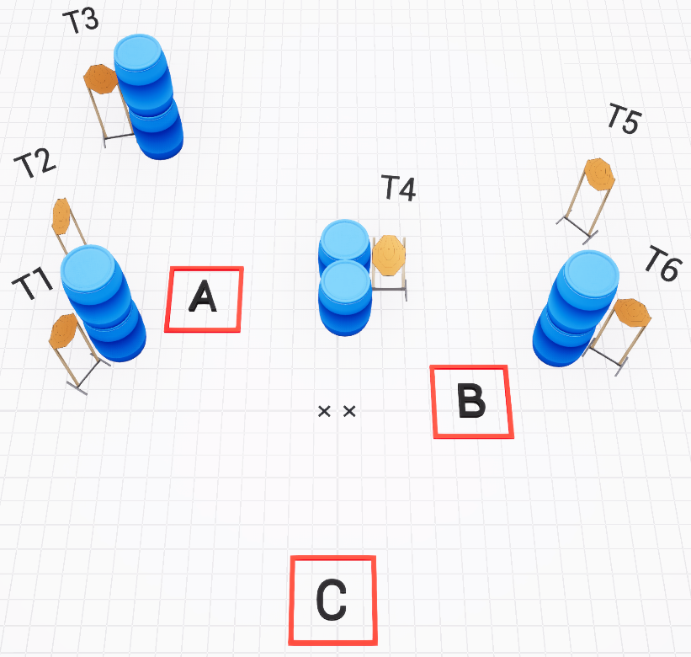

SETUP NOTES: All targets should only be visible from any 2 of the 3 boxes. |  | RO NOTES:

